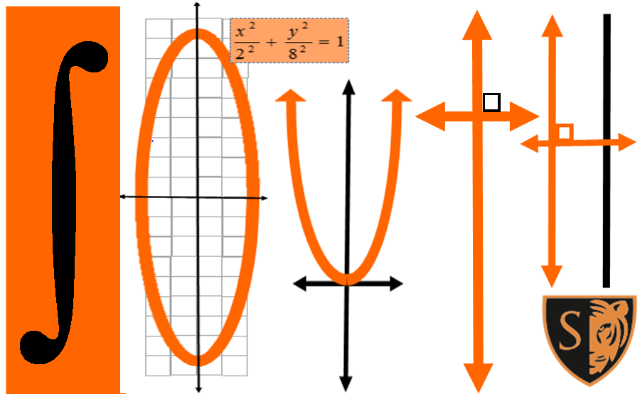
R O O M
219

Math Department

PERIOD | CLASS | TEACHER
1 |  | Note: Ms. VanDerWerf is in  Room 235, Math Center 1st Hour
2 | Advanced Algebra | Ms. Van Der Werf
3 | Advanced Algebra | Ms. Van Der Werf
4 | Advanced Algebra  Closed 3rd Lunch | Ms. Zobott
5 | Advanced Algebra | Ms. Van Der Werf
6
7 | Advanced Algebra | Ms. Van Der Werf
R O O M
220

Math Department

PERIOD | CLASS | TEACHER
1 | College Prep  Algebra & Statistics | Ms. Hill
2 | Geometry | Ms. Hill
3 | College Prep  Algebra & Statistics | Ms. Hill
4 | College Prep  Algebra & Statistics  Closed 2nd Lunch | Ms. Hill
5
6 | Geometry | Ms. Hill
7 | Intermediate Algebra | Mr. Griffin
R O O M
221

Math Department

PERIOD | CLASS | TEACHER
1 | Algebra Geometry Statistics | Mr. Winnes
2
3 | AP AB Calculus | Mr. Winnes
4 | AP AB Calculus  Closed 2nd Lunch | Mr. Winnes
5
6 | Algebra Geometry Statistics | Mr. Winnes
7 | Algebra Geometry Statistics | Mr. Winnes
R O O M
222

Math Department

PERIOD | CLASS | TEACHER
1 | Intermediate Algebra | Mr. Griffin
2 | AP Computer Science Principles | Mr. Griffin
3 | AP Computer Science Principles | Mr. Griffin
4 | Intermediate Algebra Closed 1st Lunch | Mr. Griffin
5 | Intermediate Algebra | Mr. Schultz
6 | Intermediate Algebra | Mr. Schultz
7 | Intermediate Algebra | Mr. Schultz
R O O M
223

Math Department

PERIOD | CLASS | TEACHER
1
2 | Intermediate Algebra | Mr. Galinson
3 | Black Culture | Mr. Magembe
4 | Geometry  Closed 2nd Lunch | Mr. Galinson
5 | Geometry | Mr. Galinson
6 | Geometry | Mr. Galinson
7 | Geometry | Mr. Galinson
R O O M
227

Math Department

PERIOD | CLASS | TEACHER
1
2 | Intermediate Algebra | Ms. Benjamin
3 | Math Support | Ms. Benjamin
4 | Intermediate Algebra Closed 3rd Lunch | Ms. Benjamin
5 | Intermediate Algebra | Ms. Benjamin
6 | Geometry | Ms. Benjamin
7
R O O M
228

Math Department

PERIOD | CLASS | TEACHER
1 | Geometry | Mr. Niemiec
2 | Intermediate Algebra | Ms. Zobott
3 | Geometry | Mr. Niemiec
4 | AP Statistics  Closed 2nd Lunch | Mr. Niemiec
5 | Intermediate Algebra | Ms. Zobott
6 | Intermediate Algebra | Ms. Zobott
7 | AP Statistics | Mr. Niemiec
R O O M
229

Math Department

PERIOD | CLASS | TEACHER
1 | Intermediate Algebra | Mr. Krasean
2 | Advanced Algebra | Ms. Fierst
3 | AP Statistics | Ms. Fierst
4 | Intermediate Algebra Closed 3rd Lunch | Mr. Krasean
5 | AP BC Calculus | Mr. Krasean
6 | Advanced Algebra | Ms. Fierst
7 | Advanced Algebra | Ms. Fierst
R O O M
231

Math Department

PERIOD | CLASS | TEACHER
1 | Pre-Calculus | Mr. Schultz
2 | Pre-Calculus | Mr. Schultz
3 | Intermediate Algebra | Ms. Woldum
4 | Intermediate Algebra Closed 2nd Lunch | Ms. Woldum
5 | Intermediate Algebra | Ms. Woldum
6
7 | Geometry | Ms. Woldum
R O O M
232

Math Department

PERIOD | CLASS | TEACHER
1 | Intermediate Algebra | Ms. Leblanc
2 | Health | Ms. Field
3 | Intermediate Algebra | Ms. Leblanc
4
5 | Pre-Calculus | Ms. Leblanc
6 | Intermediate Algebra | Ms. Leblanc
7 | Pre-Calculus | Ms. Leblanc
R O O M
238

Math Department

PERIOD | CLASS | TEACHER
1 | Geometry | Ms. Loichle
2 | Geometry | Ms. Loichle
3 | Geometry | Ms. Loichle
4 | Honors Geometry  Closed 3rd Lunch | Ms. Loichle
5 | Honors Geometry | Mr. Rumppe
6 | Honors Geometry | Mr. Rumppe
7 | Honors Geometry | Mr. Rumppe
R O O M
251

Math Department

PERIOD | CLASS | TEACHER
1 | Advanced Algebra | Mr. Sepeda
2
3 | Advanced Algebra | Mr. Sepeda
4 | Pre-Calculus  Closed 2nd Lunch | Mr. Rumppe
5 | Math Support | Mr. Sepeda
6 | Advanced Algebra | Mr. Sepeda
7 | Math Support | Mr. Sepeda
R O O M
228

Math Department

PERIOD | CLASS | TEACHER
1 | Geometry | Mr. Niemiec
2 | Intermediate Algebra | Ms. Zobott
3 | Geometry | Mr. Niemiec
4 | AP Statistics  Closed 3rd Lunch | Mr. Niemiec
5 | Intermediate Algebra | Ms. Zobott
6 | Intermediate Algebra | Ms. Zobott
7 | AP Statistics | Mr. Niemiec

