Daily Practice 6A * Review of ‘Solving Systems of Linear Equations’.

Directions:
Tomorrow we are starting Unit 6 on Solving Systems of Equations & Inequalities (including using matrices). In past math courses you have learned several methods for solving a system of 2 linear equations. Take a minimum of 10 minutes to read the GREEN ‘Review: Solving Systems of Linear Equations’ page. Answer the following questions.

1) How are the 8 methods for solving systems of linear equations similar?

2) Which method(s) for solving systems of equations do you feel most comfortable with?
Why?

3) Which method(s) for solving systems of equations do you feel like you need more help with?
Explain.

4) Record three things that you learned or were reminded of after reading this document.

a)

b)

c)

(over)
Below are the test questions from an 8th/9th grade math test on this topic. Look through all the problems below. In this test, 8th/9th grade students were asked to solve all the problems below using a different method for each problem.

Match each set of equations below (#1-8) with the method (look at the GREEN sheet for help)
you believe would be most efficient for solving the systems listed. Justify your choice.

a. Elimination  with Subtraction | b. Elimination  with Addition | c. Graphing  by Hand | d. Graphing  with Desmos
e. Substitution | f. Set Equals Method (y= or x=) | g. Identify as having No Solution | h. Identify as having Infinite Solutions

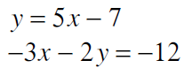 | 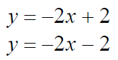  5.
2. x = 5 - y  x = 2y +2 | 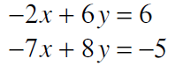  6.
- Bob buys 8 gallons of paint & 3 brushes for $152.50. The next day he buys 16 gallons of paint & 6 brushes for $305. How much does each gallon of paint and each brush cost? Write a system of equations and be sure to define the variables. | 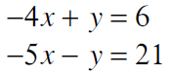  7.
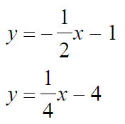  4. | 8. The school that Stefan goes to is selling tickets to a choral performance. On the first day of ticket sales the school sold 9 senior citizen tickets and 3 child tickets for a total of $114. The school took in $52 on the second day by selling 3 senior citizen tickets and 2 child tickets. Find the price of a senior citizen ticket and the price of a child ticket. Write 2 equations representing this information. Be sure to define your variables. Solve.
Review: Solving Systems of Linear Equations.
a. Elimination with subtraction. (-) | b. Elimination with addition. (+)
Example: multiply the 1st equation by 2  $5x+2y=30$ → 2($5x+2y=30)$→ $10x+4y=60$  $10x+3y=55$ → → -($10x+3y=55)$  Substitute value of y into one equation & solve for x. 1y = 5  5x + 2(5) = 30 → 5x + 10 = 30  -10 -10  5x = 20  5 5 x = 4  These 2 lines intersect at the point (4, 5).  HINT: Use this method if it is easy to multiply one equation (in this example, multiply the 1st equation by 2) by a constant so that either ‘x’ or ‘y’ have the same coefficients. | Example:  $-8x+2y=4$ → $-8x+2y=4$  $-3x-2y=-15$ →+($-3x-2y=-15$)  -11x = =11 ← divide by -11 x=1  Substitute the value of x into one equation and solve for y.  $-8(1)+2y=4$ → -8 + 2y = 4  +8 +8 The 2 lines intersect  2y = 12 at the point (1, 6)  2 2 y = 6  HINT: Use this method if the 2 equations have a variable with positive & negative coefficients with the same value. In the example above the y-variables have coefficients of 2 & -2. If you add the 2 equations, you eliminate the y-variable.
c. Graphing by hand. | d. Graphing with Desmos.
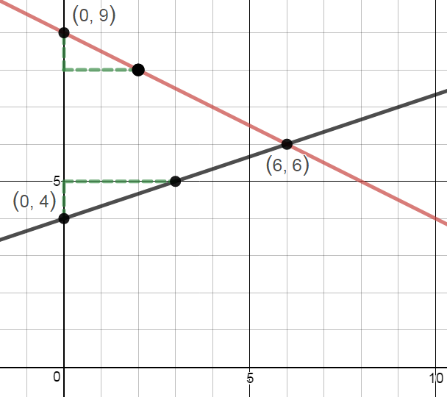  Example:  $y=\frac{1}{3}x+4$  $$y=\frac{-1}{2}x+9$$  1st , graph the y-intercepts of each equation. Use the slope $\left(\frac{rise}{run}\right)$ to find points on the line.  The point (6,6) is  the solution to the system of equations.  HINT: Use this method if both equations are written in slope-intercept form. (y=mx+b).  ‘m’ is the slope & ‘b’ is the y-intercept. | 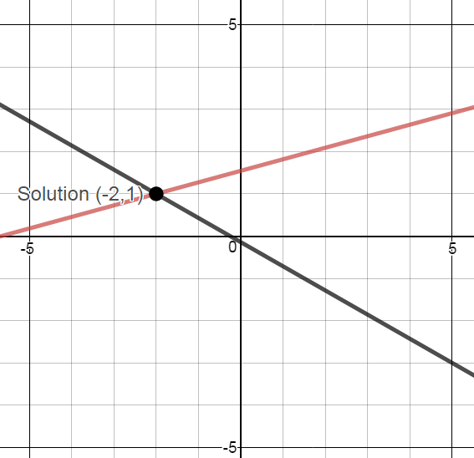  Example:  $$-4x-7y=1$$  $$-3x+11y=17$$  Sign on to www.desmos.com or use the Desmos App on your phone. Enter both equations. Tap on the intersection point.  The point (-2,1) is  the point where x & y have the same values in both equations.  HINT: Use this method for any type of system. Desmos is great if a system involves negative or large numbers.
e. Substitution. | f. Set Equals Method (y= or x=).
Example:  $y=2x-5$ substitute ‘2x-5’ into the equation for ‘y’  $-3x+4y=-5$→ -3x + 4(2x-5) = -5 ←distribute 4  -3x + 8x -20 = -5 ←combine line terms  5x – 20 = -5 ←add 20 & divide by 5  +20 +20  5x = 15 → so. x = 3 ←substitute this into  y=2(3) – 5=6-5 = 1 → y = 1 the 1st equation.  HINT: Use this method if one equation is equal to ‘x’ or ‘y’. Substitute one equation into the other equation and solve for the first variable. In this example we started by substituting ‘2x-5’ into the other equation for ‘y’ and solved for ‘x’. | Example:  $x=5+y$ 5 + y = 4y – 4  $x=4y-4$ -1y -1y  5 = 3y – 4  +4 +4  9 = 3y  3 3 y=3  Substitute the value of y into either original equation to solve for x.  x= 5 + (3) → x = 8  HINT: Use this method if both equations are equal to ‘x’ or both equal to ‘y. In this example both equations are equal to ‘x’. Set the 2 equations equal to one another and solve for ‘y’.
g. Identify as having ‘No Solution’. | h. Identify as having ‘Infinite Solutions’.
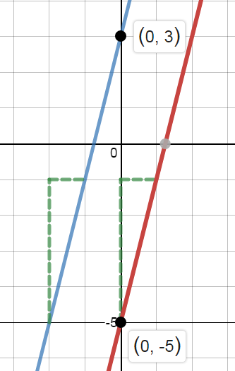  Example:  $y=4x-5$ → the slope of this line is ‘4’.  $y=4x+3$ → the slope of this line is ‘4’.  HINT: A system has ‘no solution’  1  1  If the 2 lines do not intersect.  This happens if the 2 lines are parallel.  If both equations have the SAME slope  4  4  (In this example the slope of each  equation is 4.) then the lines are  parallel & have no solution. | 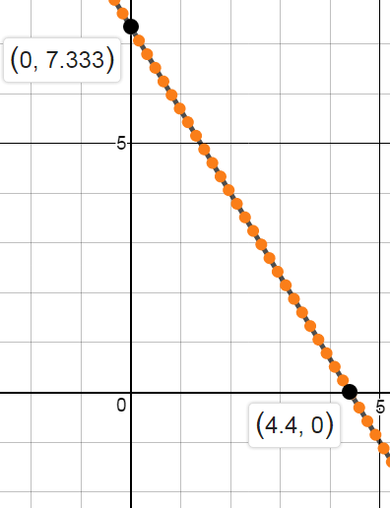  Example:  $5x+3y=22$ → 3($5x+3y=22)$  $15x+9y=66$ 15x + 9y = 66  This is the same equation.  HINT: A system has ‘infinite solutions’  If the 2 lines intersect everywhere.  This happens if the 2 lines coincide  (same line/equation). If the 2 equations  are multiples of one another (In this  example the 2nd equation is 3x larger than  the first equation), then the 2 lines  coincide giving multiple solutions.

