Solving Systems of Inequalities Reference Sheet
Definition of ‘System of Inequalities’ |  | Feasible Region (Solution to a system of Inequalities)
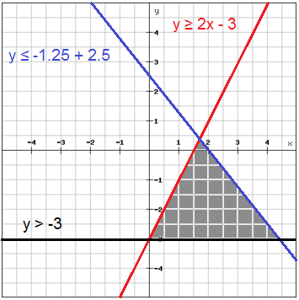  A system of inequalities consists of 2 or more functions that each include one inequality symbol (<, >, <, or >).  For example, this is a  System of Inequalities.  Feasible  Region  (22/13, 5/13)  $$\left\{\begin{aligned}y≥2x-3 \\ y≤-1.25x+2.5 \\ y>-3\end{aligned}\right.$$  The solution is represented by the shaded gray area in the graph. This shaded area is called a ‘feasible region’. The vertices of this feasible region are  (4.4,-3)  (0,-3)  (0, -3), (4.4, -3) and $\left(\frac{22}{13}, \frac{5}{13}\right)$. |  | - The ‘feasible region’ is the SOLUTION to the system of inequalities.  - A ‘feasible region’ is a collection of points (ordered pairs) that satisfy (make true) all inequalities in the system.  - On a graph the solution to a system is represented by a bounded or unbound shaded region.  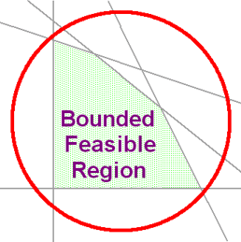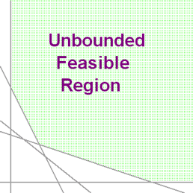
Inequality Symbols |  | Test Point (to determine which side to shade)
$$<$$  “Is less than”  - Open circles  - Dashed/dotted lines or curves. | $$>$$  “Is greater than”  - Open circles  - Dashed/dotted lines or curves. | 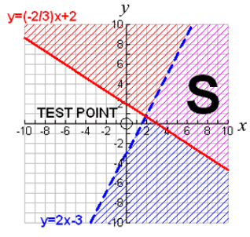  - Use a ‘test point’ to determine which side of the function to shade.  - Select a point that is easy to work with. 90% of the time the point (0,0) is a good point to select.  - If using (0,0), substitute 0 in for both the x & y variable in each function.  FALSE!  - Determine if the inequality statements are ‘true’ or ‘false’.  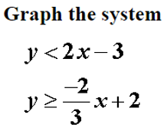  TEST POINTS  y < 2x – 3 y > -2/3x + 2  0 < 2(0) – 3 0 > -2/3(0) + 2  0 < -3 0 > 2  FALSE! FALSE!    - Since both equations are false, shade the side of each function that does NOT include the ‘test point’ (0,0)  F  - The solution, S, is where the two shadings overlap one another.
$$≤$$  “Is less than or equal to”  - Filled Circles  - Solid Lines or curves. | $$≥$$  “Is greater than or equal to”  - Filled Circles  - Solid Lines or curves.
How to shade a feasible region * OPTION #1 |  | How to shade a feasible region * OPTION #2
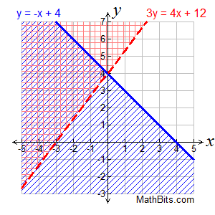  - Shade each inequality seperately using either a different color or direction (cross-hatching) of shading.  - The feasible region is the overlap of the 2 shaded regions. |  | 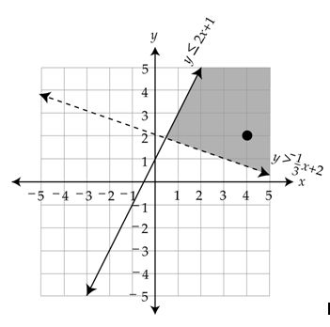  - Represent the areas to be shaded for each line using tiny arrows pointing in the direction to be shaded.  - Shade only the feasible region identified by the area where both sets of arrows point.
Graphing Inequalities Reference Sheet

Horizontal (linear) Inequalities  Inequality: y < 1 | Vertical (linear) Inequalities  Inequality: x < -3
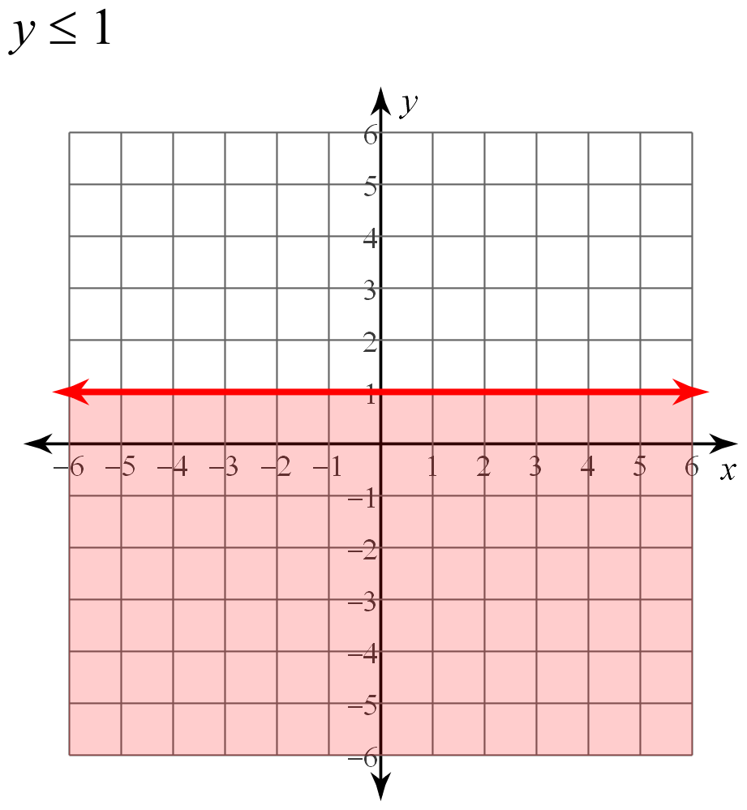  (0, 1)  When you have an inequality in the forms:  y > #  y < #  y ≥ #  y ≤ #  The graph will ALWAYS be a HORIZONTAL line. | 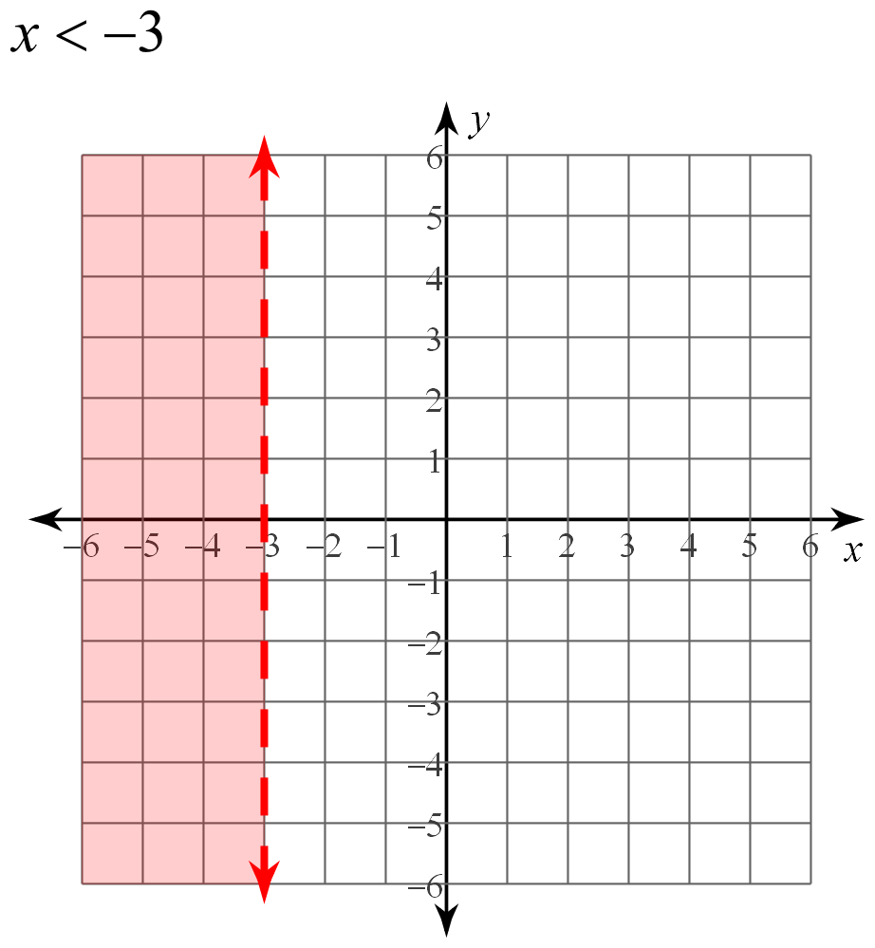  When you have an inequality in the forms:  x > #  x < #  x ≥ #  x ≤ #  The graph will ALWAYS be a VERTICAL line.  (-3, 0)
Intercept Form – Linear Inequality | General Form – Linear Inequality
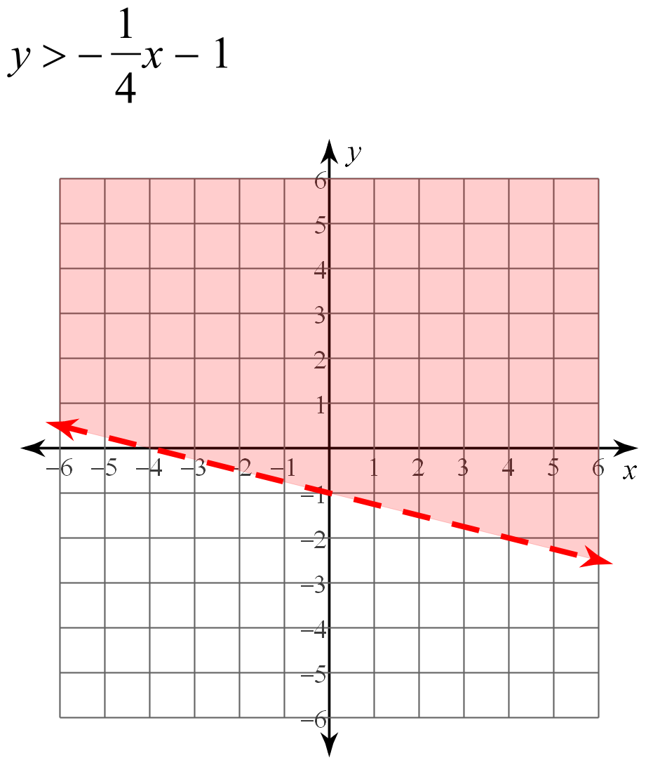  (4, -2)  Inequality: $y >-\frac{1}{4}x-1$  m b  This inequality is in slope-intercept form: y>mx + b  ‘b’ is the y-intercept, found at (0, -1)  ‘m’ is the slope $\left(\frac{rise}{run}\right)$  Start at the y-intercept and go down 1 unit and over 4 - ending at (4, -2)  (0, -1) | 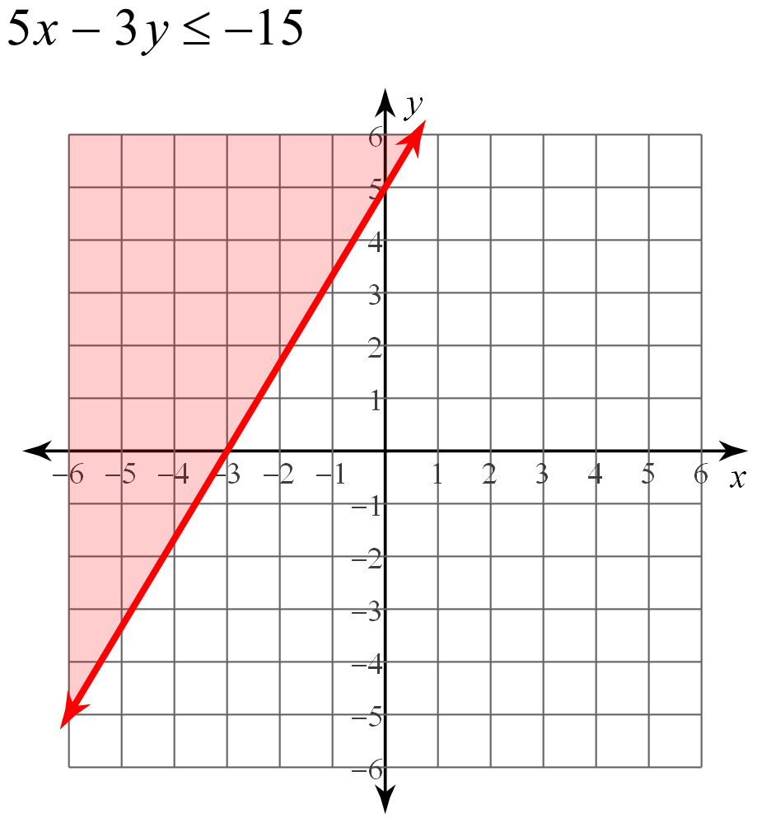  A B C  Inequality: $5x-3y ≤-15$  This inequality is in general form form: Ax + By < C  To graph the inequality find both the ‘x’ and ‘y’ intercepts by substituting zero, 0, in for x and y.  (0, 5) and (-3, 0)  (-3, 0)  (0, 5)
Quadratic Inequality | Absolute Value Inequality
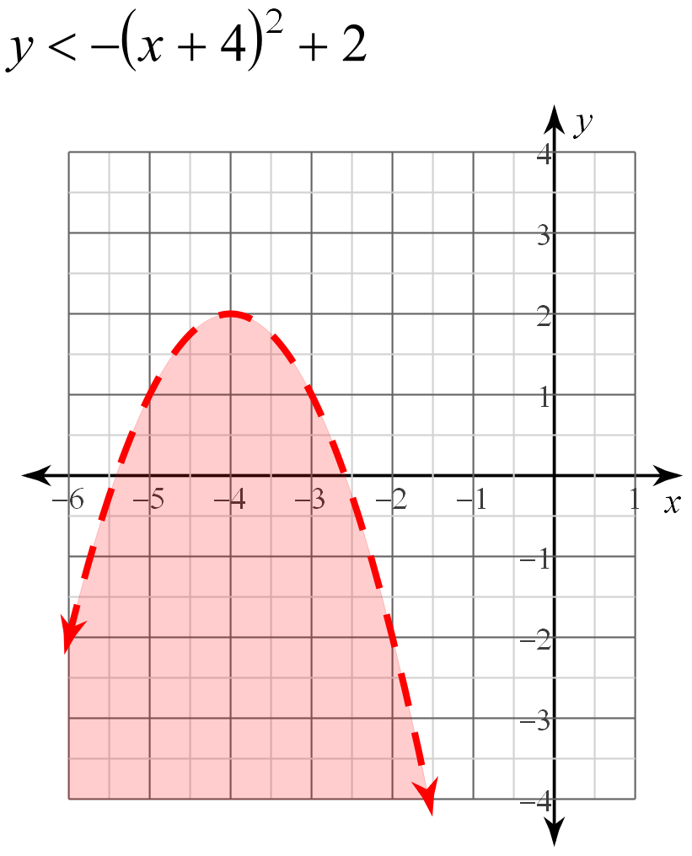  a h k  This inequality is written in vertex form: y<a(x-h)²+k  The vertex is found at (h, k) or (-4, 2).  The ‘a’ value is negative so you must reflect the parabola.  Inequality: $y<-{\left(x+4\right)}^{2}+2$  (-4, 2) | $y≤\left|x-3\right|-1$  a h k  Inequality: $y≤\left|x-3\right|-1$  (3, -1)  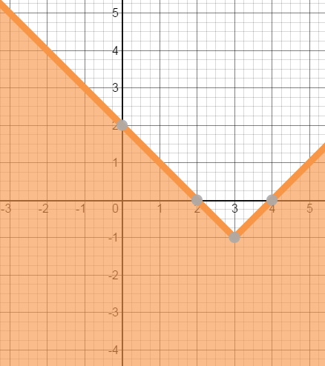  This inequality is written in the form: $y≤a\left|x-h\right|+k$  The vertex is found at (h, k) or (3, -1).  The ‘a’ value is positive so the graph opens upward.

